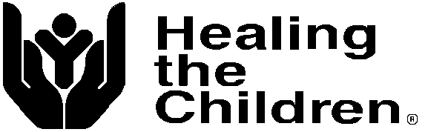

**Florida/Georgia, Inc. Tax I.D. # 59-3503974**

**PO Box 608432 Phone Voice: 1 407 877 9311**

**Orlando, Florida 32860**

**HEALING THE CHILDREN FLORIDA, INC., ANNUAL REPORT – 2023**

Healing the Children Florida, Inc., is a Florida (HTCFLA) based not for profit organization holding a 501 © (3) tax exemption with the IRS. Our tax-exempt number is 59-3503974. HTCFLA provides specialized medical treatment to children in need worldwide including the USA.

These services are provided through four core service programs detailed below:

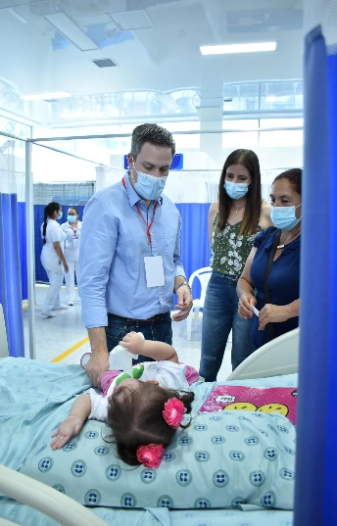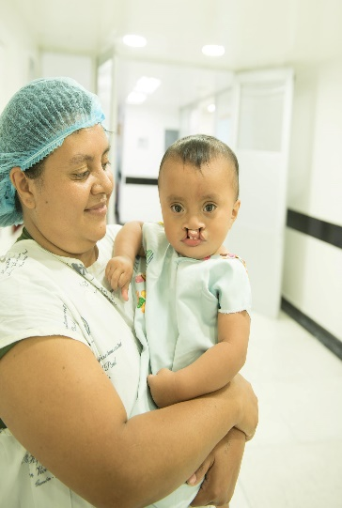

**Medical Trips Program -**

As an organization working internationally to meet the needs of poor children in

developing countries, HTC organizes and transports volunteer surgical teams to a preselected and approved hospital site. Sites must meet specific and well-defined criteria before being considered as a program site for HTC. Local and national governmental and civic relationships are established to ensure a smooth implementation of our program, which will maximize benefits to our patients.

During 2023, HTC Florida conducted (2) medical trips. These included trips, 1 trip to Colombia specializing in orthopedics, oral maxillofacial and plastic surgery.

203 patients were screened and 63 were selected for surgery.

The orthopedic team performed surgery on 28 patients and follow up care/surgery was provided for 34 patients.

HTC Telemed Medical Team, Nigeria 6 medical outreach teams were 223 patients received blood pressure checks, pulse and oxygen saturation was taken. Blood glucose levels and hemoglobin checks were also performed. Prostate screening was performed on men. Counseling services were provided regarding the accessing services through telemedicine and health talk were held. Services were also provided through telehealth using OhanaOne glasses which enabled medical professionals to screen and treat patients remotely.

A total of 426 patients were screened and evaluated by our volunteer team members. The patients selected for surgery/ medical care provided with donated care were 286. Estimated donated services provided were $ **800,000.00.**

.

Healing the Children, Florida is grateful to all their donors and sponsors. Thank you also to all our donors, volunteers, and friends for their continued commitment to the Healing the Children mission - “Healing the Children, Around the Corner, Around the World!”

**Domestic Program** – (Aid to American Kids)

This program aims to provide children with life changing and life altering medical care.

Due to the increasing number of children who remain uninsured due to parental

immigration status, parents’ lack of awareness of service available to them and financial

constraints, many children with special medical needs, go untreated or identified. Healing the children has partnered with local clinics and agencies to help meet the needs of these children. We have made arrangements to utilize office in the Central Florida area to address the needs of local children.

Its primary focus is to treat the special medical, developmental needs

of needs of children from low income families, who have no health insurance and

are not eligible for any insurance or programs, even those at a local or state level. Our

secondary focus is to identify those families whose child’s special condition puts the

family in financial crisis despite having health insurance. HTC receives and accepts referrals from local agencies such as local clinics, the health departments, and professional healthcare providers. We recruit specialist from varying medical areas.

H TC also provides transportation and prescription assistance when necessary. Area volunteers are recruited to provide transportation to and from clinic appointments as needed. If a volunteer is not available, we provide some financial assistance for bus fare or a gas card is provided. As well as providing specialized care, HTC provides educational information that addresses and encourages good health as well as child safety. Our primary care physician referral network continues to match uninsured children with a volunteer physician in the community willing to accept the patient at no cost to the parents. Our case management staff carefully screens each patient and makes the appropriate referral to a specialist, who has the responsibility of accepting or not accepting the referral. One of our major goals is to decrease the number of children with special medical and developmental needs not receiving care due to lack of insurance or financial constraints. Our success is measured by the number placements we make and the acceptance by a healthcare provider for treatment of the children we identify and are deemed treatable by the treatment team.

The direct and indirect outcomes of our project are -

. an increase in the quality of life and life expectancy of the children we serve;

. decrease in familial stress;

. decrease in the number of children living in poverty who lack proper medical health.

. decrease the number of emergency room visits made by families with children who

have special needs, who use the E.R. as a primary care provider.

Healing the Children strives to significantly increase the quality of medical treatment to

children in our local communities who lack appropriate medical care. As an organization HTC takes great pride in the high-level professional care we are able to provide for our patients. We believe in our mission and through the actions of our volunteers and results, we have proven to be a leader in the field of humanitarian health care. Our volunteers are dedicated individuals who have selflessly given of their time to provide medical care in extraordinary circumstances. We are confident in our ability to dynamically impact the lives of children who are in dire need of medical care in our local communities.

Healing the Children Florida, Inc. is a member of CFC and local United Ways.

During 2023, 9 children were provided in-kind services totaling $ 21,795. Services provided included access to surgeries, appointments with medical specialists, ancillary support services, therapeutic camps, advocacy support and case management services. Thank you also to all our donors, volunteers, and friends for their continued commitment to Healing the Children.

**The International Medical Assistance Program (IMAP)** uses collaborative contacts to help find medical care for a child in a country closer to where he/she lives. We provided support such as surgery, lab work, x rays to 3 children in Liberia and 1 from Belice for estimated cost of $2, 400.00

Special Project Support:

**Home of Bright Choices:** Healing the Children recently partnered with Home of Bright Choices a new not for profit dedicated to filling gaps for individuals with special needs with life skills and independent living skills. The estimated cost of donated services through this partnership is $15,000.00.

The total amount of in services provided to the patients we

served during 2023 was $ 821,895.00

Healing the Children Florida, Inc, was able to accomplish all of its goals for 2023 on a combined income of $**81,203.80 .**

Healing the Children Florida/Georgia